Colorado River Association of the Deaf and Hard-of-Hearing
and The City of Lake Havasu in Arizona Cordially Invite You To:
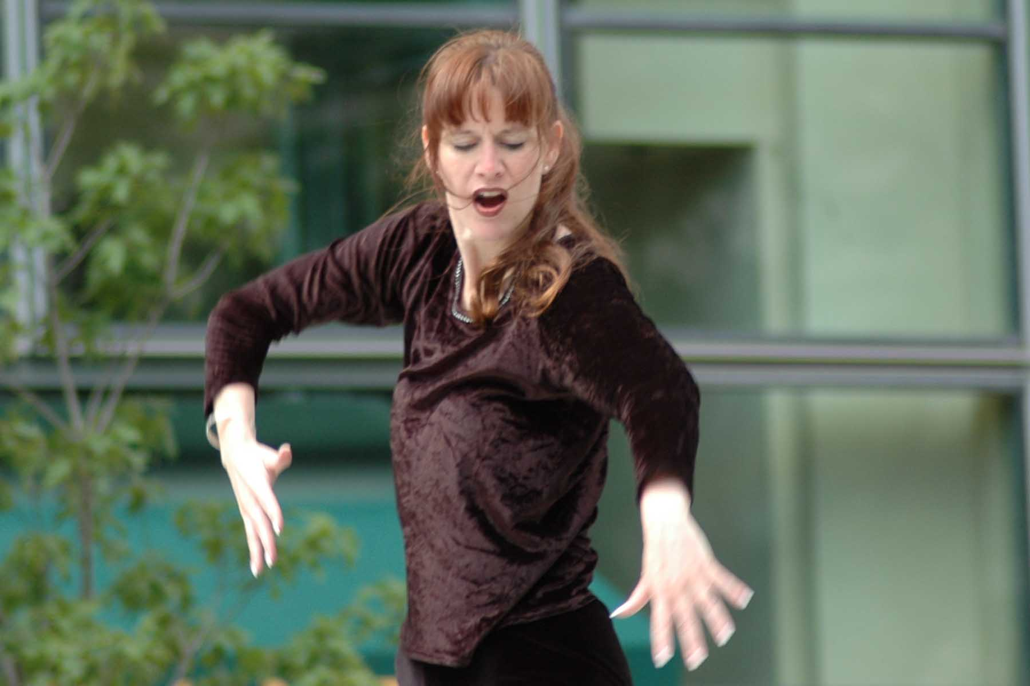
“SPOKEN SILENCE”
One full day of workshop and amazing performance by the celebrated Deaf Artist, Poet and Storyteller:
Trix Bruce

During the celebration and commemoration of the London Bridge in Lake Havasu City, Trix Bruce will conduct a full day workshop, “Drawing In Space With ASL Classifiers” and give two performances on what she does best, “Tales of a Mad, Mad, Mad ASL World.”
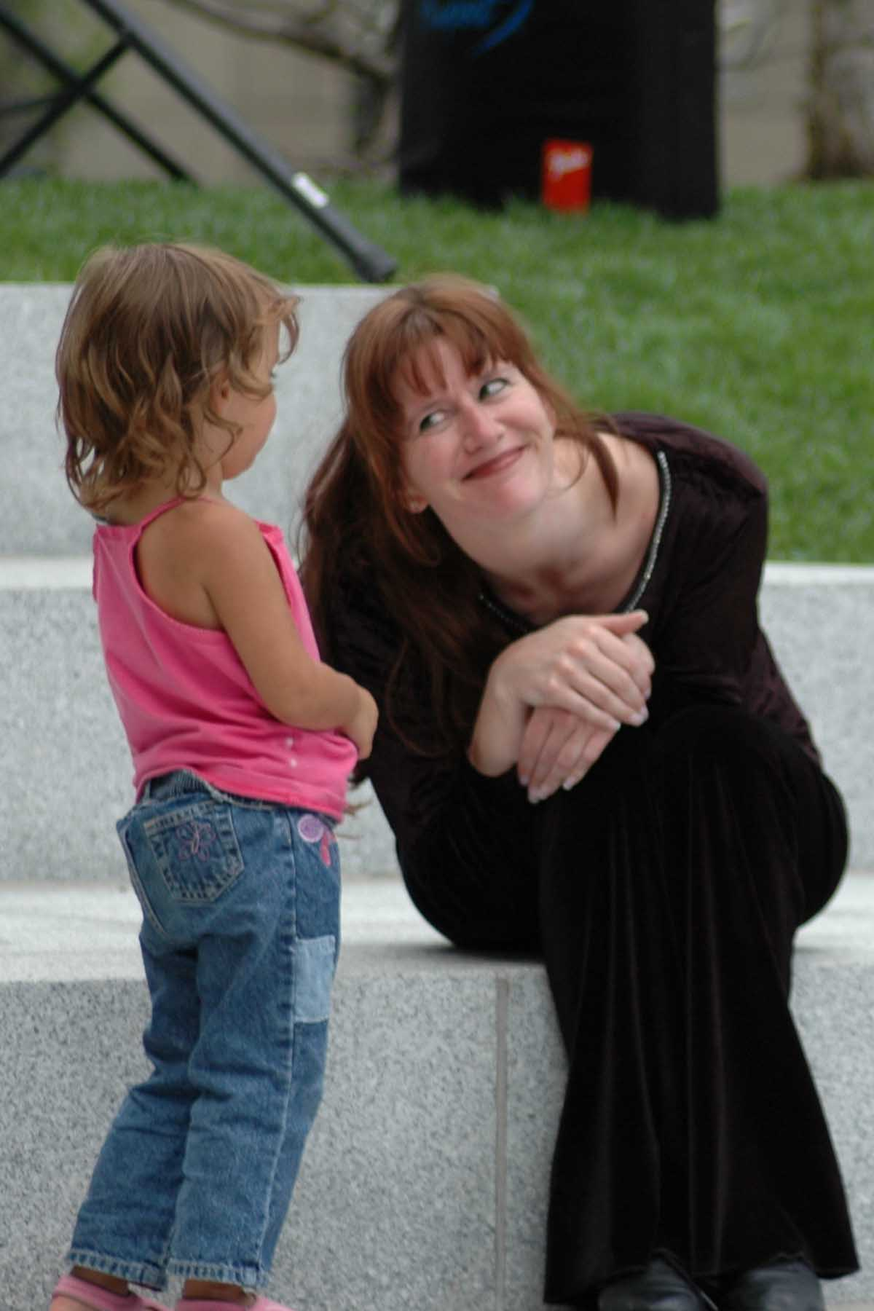
October 28 (Friday)
9:00 AM until 4:00 PM – Classifier Workshop (0.7 Professional Studies RID CEU)
This whole day workshop will provide you with hands-on experience and skill building activities for appropriate classifier use applied to complex descriptions and images. Complicated and confusing pictures, eye gaze, role shifting, spatial referencing and appropriate use of classifiers in storytelling will also be presented. Emphasis is placed on developing the ability to “visualize in pictures” as a way to improve expressive and receptive communication skills.
- Handouts and Trix’s DVD about Classifiers will be provided at this workshop
Open to all interpreters, teachers, and signers from of various levels
Scheduled at the London Bridge Resort

6:00 PM until 8:30 PM – Performance (0.1 General Studies RID CEU)
In a spell binding mixture of ASL, poetry, mime, storytelling and folktales, Trix performs her one-woman show. Even though no words are spoken, this performance will leave not only those who understand ASL, but she captivates those who don’t!
Scheduled at the London Bridge Resort

October 29 (Saturday)
10:00 AM until Noon - London Bridge Day Parade,
Trix Bruce showing her stuff during the parade!

2:30 until 5:00 – Encore Performance
Trix Bruce with more poetry, mime, and storytelling
Scheduled at the London Bridge Resort

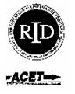

Admission Fees
EVENT | CRADHH MEMBER | NON-MEMBER | INCLUDES
Prepaid Complete Package | $250.00 | $250.00 | Workshop, Performance, One night @ Ramada Hotel (Friday) w/ 3 meals
Prepaid Performance Package | $ 150.00 | $ 150.00 | Performance, One night @ Ramada Hotel (Friday) w/ 2 meals
Performance Only; adults | $ 25.00 | $ 30.00 | One performance, Friday night or Saturday afternoon
Performance Only, ages 3 to 12 | $ 10.00 | $ 10.00 | One performance, Friday night or Saturday afternoon
Workshop Only (no children) | $ 75.00 | $ 100.00 | Workshop, Friday morning and afternoon, Handouts, DVD and Lunch
Membership Fees
Regular: $15.00 per year
Senior, 55 and older: $7.50 per year
Student, with valid ID: $10.00 per year

